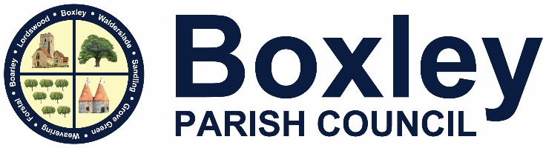
Beechen Hall, Wildfell Close, Walderslade, Chatham, Kent. ME5 9RU
01634 861237
clerk@boxleyparishcouncil.org.uk
Clerk: Mrs Daniela Baylis
Assistant Clerk: Heidi Pearson
Finance Assistant: Nichola Carter

www.boxleyparishcouncil.org.uk

A G E N D A

To All Members of the Council, Press and Public

There will be a meeting of the Environment Committee on Monday 11 March 2024 at 7.30pm at Beechen Hall, Wildfell Close, Walderslade, ME5 9RU.

- Apologies and absences
To receive and accept apologies for absence.

- Declaration of Interests, Dispensations, Predetermination or Lobbying
Members are required to declare any interests, dispensations, predetermination or lobbying on items on this agenda. Members are reminded that changes to the Register of Interests should be notified to the Clerk.

Public Session at the discretion of the Chairman. Parishioners may address the meeting with regard to any item on the Agenda (time limited to 3 minutes per person). Items not on the Agenda must be submitted to the Clerk in advance of the meeting. Non-parishioners are only able to address the meeting at the invitation of the Chairman.

- Minutes of the Meeting held on 5 February 2023 (previously circulated)
To consider the minutes and if in order sign as a true record.

- Matters Arising from the Minutes
Any other matters arising from the minutes not on the agenda.

- Planning Applications for Consideration – DECISION
To consider applications received.

- Ratifications

- Planning Decisions, Appeals and Appeals Decisions – INFORMATION
To receive and consider any information.

- Highways and Byways - DECISION
8.1 Highways Improvement Plan.
8.2 Junction 3 of the M2/Bluebell Hill
8.3 A249 Bearsted Road Major Infrastructure Project.
8.4 Boxley Village
8.6 Any Highways issues raised at the meeting.

- Policy and Procedure – Review

- Task List

- Members and Officer’s Reports
11.1 To receive any reports or notification of issues from members

- Residents’ Concerns

- Consultations
None on this Agenda

- Volunteer Groups – INFORMATION
To receive any reports.

- Items for Next Agenda – DECISION
Requests for items to be included on the next agenda.

- Next Meeting
Next Environment Committee meeting 8 April 2024.

In view of the confidential nature of the item about to be transacted, it is advised that the public and press will be excluded from the meeting for the duration of the following items.

- Enforcement and CIL/Section 106 updates from MBC
To consider any updates received.

Daniela Baylis
Daniela Baylis
Clerk to Boxley Parish Council Date: 4 March 2024

